Homework 13

Asiqul Hoque

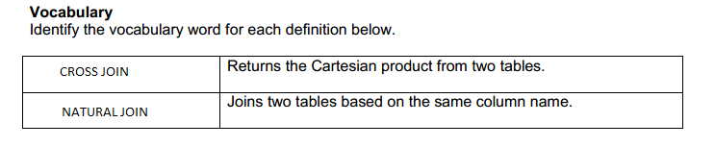

1. select last_name, department_name  
from departments CROSS JOIN employees;

2. The query from the first question returns data from both the departments table and employees table because of the use of CROSS JOIN.

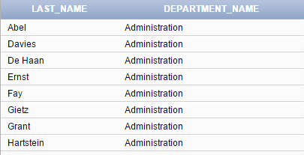

3. select department_id, department_name, location_id, city  
from locations NATURAL JOIN departments;

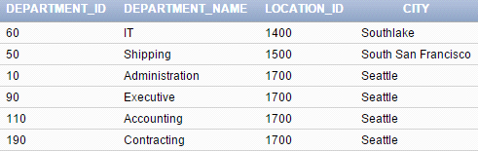

4. select department_id, department_name, location_id, city  
from locations NATURAL JOIN departments  
where department_id IN(20, 50);

